Eblast/Newspaper Article & Nextdoor/Neighborhood Blog/Nixel Messaging

Sample Header:
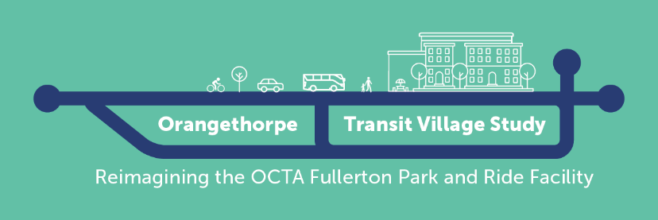
For use any time before March 20th:

Title: Help OCTA envision the future of the Fullerton Park and Ride!

Body:
The Orange County Transportation Authority (OCTA), in partnership with the City of Fullerton, is leading the Orangethorpe Transit Village Conceptual Study to explore development concepts, key amenities, and priorities for improving site access and traffic flow.

OCTA values your feedback! In the first community survey conducted in Fall 2024, you provided valuable feedback on riding habits, preferred transit-supportive features, and facility improvements at the Fullerton Park and Ride. Now, OCTA is seeking more input on development concepts, key amenities, and priorities for improving site access and traffic flow.

Be part of the planning process by providing your input at a community meeting or by taking an online survey!

Here is how to get involved:

Attend the Virtual Community Webinar
Thursday, March 20th at 6 pm
Meeting ID: 891 1863 9349
Call-In: +1 (213) 338-8477
Register here!

Spanish Call In-Line: +1 (224) 501-3412
Access Code: 960-947-773

Korean Call In-Line: +1 (571) 317-3122
Access code: 478-136-597

Attend an In-Person Meeting:
Wednesday, March 26th at 6 pm
Fullerton Community Center – Classroom 1A
340 W Commonwealth Ave.
Fullerton, CA 92832

The presentation will be 15 minutes after the event begins.
Refreshments and children’s activities will be provided.

Participate in the Online Survey
Take the survey by April 7th for a chance to win one of two $50 gift cards!

Learn more about the plan and how you can get involved by visiting octa.net/FullertonPnR.

