**Program Overview**

**ATTACHMENT A**

The Arterial Pavement Management (APM) Program has been developed to address pavement maintenance in Orange County. The APM Program will seek to provide cost-effective treatments that will preserve or improve the functional pavement condition and extend the service life for distressed arterials in the County. Specifically, the APM Program is designed to fund pavement preservation, rehabilitation, and/or reconstruction projects for federally eligible projects on the Master Plan of Arterial Highway (MPAH).

# Eligible Applicants

Eligible applicants for this program include the 35 local government agencies in Orange County. Eligible agencies must be able to receive federal funding through Orange County Transportation Authority (OCTA) funds, and must be able to provide authorizing resolutions and cooperative agreements from their controlling bodies or through the California Department of   
Transportation (Caltrans) as a direct recipient of Federal Highway Administration (FHWA) funds. Two or more eligible local agencies may participate on a project.

**Eligible Expenditures**

The following general type of projects will be eligible under this program:

* **Pavement Preservation/Preventative Maintenance**: Considered in this call for projects as arterials with Pavement Condition Index (PCI) of (60-85). Treatments can include slurry seals, microsurfacing, crack seals, and similar sealing non-structural treatments.
* **Rehabilitation**: Work undertaken to extend the service life of an existing facility. This includes placement of additional surfacing and/or other work necessary to return an existing roadway, including shoulders, to a condition of structural or functional adequacy, for the specified service life. This might include the partial or complete removal and replacement of portions of the pavement structure. Arterials with a PCI of (41-74) are eligible for this category. Pavement rehabilitation consists of a variety of different treatments thin overlays which are a maximum of 1.2 inch (30 mm) in thickness[1], thick overlays or structural overlays, Cold In-Place Recycling, Hot In-Place Recycling, etc., but should not include preventive maintenance treatment.

* **Reconstruction**: Pavement reconstruction is the replacement of the entire existing pavement structure by the placement of the equivalent or increased pavement structure. Reconstruction usually requires the complete removal and replacement of the existing pavement structure utilizing either new or recycled materials. Arterials in this category are identified with a PCI rating in the range of (0-40).

For each of these projects the following expenditures will be eligible:[2]

* Construction
* Construction engineering
* Bike lanes (striping and corresponding signage only, must be on an adopted plan)
* Bus Turnouts (resurfacing only, must be on an OCTA route)
* Portland concrete cement (PCC) bus pads
* Repair or replacement in kind of parking lanes, curbs, gutters, driveway approaches, catch basins, and minor profile revisions (i.e., curb to curb) as required by project
* Use of alternative materials such as rubberized asphalt, PCC, etc.
* Construction or modification of curb ramps within the limits of the project as necessary to satisfy Americans with Disabilities Act (ADA) requirements

**Potentially Eligible Expenditures**

Items that are potentially eligible under the APM program are:

* Sidewalks if mandated for ADA type improvement/upgrade and only up to 10 percent of the total improvement costs. Must be within the limits of APM Project and located within public right-of-way.

**Ineligible Expenditures**

Items that are **not eligible** under APM are:

* Landscaping
* New parking lanes, new curb and gutter
* Utility adjustments that do not have prior rights
* Materials report or other planning activity
* Environmental documentation
* Retroactive design engineering
* Expenditures incurred prior to E-76 approval for the respective project phase

**Project Eligibility and Funding**

**Projects submitted for this program must be federally eligible and on the MPAH.** Streets or roads that are functionally classified as Minor Collector or above are eligible. Functional Classifications are identified on the California Road System Map. <http://www.dot.ca.gov/hq/tsip/hseb/crs_maps/>. In addition, only arterials designated by local agencies’ Pavement Management Plans (PMP) as having a PCI of 85 or less for preventative maintenance and 74 or less for surface treatment greater than one inch thickness in accordance with the following table shall be eligible for funding. Thickness may be adjusted for rubberized asphalt according to industry and standard practices.

Additionally, to qualify for this program the project must be implemented within a three-year timeframe. Please specify if your project will meet this deadline. Please note that after three years, your project will lose the funding if it has not yet been completed.

**Table 1: Pavement Condition Assessment Standards**

|  |  |  |  |
| --- | --- | --- | --- |
| **Condition Category** | **PCI Thresholds** | **Treatment\*** | **APM Eligible** |
| Very Good | 86-100 | None Proposed | No |
| Good | 75-85 | Preventative Maintenance | Yes |
| Fair | 60-74 | Thin Overlay | Yes |
| Poor | 41-59 | Thick Overlay | Yes |
| Very Poor | 0-40 | Reconstruction | Yes |

*Alternative treatments are eligible based on pavement management plans and material reports.

**Funding**

There will be approximately $20 million in federal Regional Surface Transportation   
Program (RSTP) available for projects in fiscal year (FY) FY 2015-16 and each APM grant must be a minimum of $250,000 and maximum of $500,000 in RSTP funds. However, projects requiring more than $500,000 can be segmented into smaller phases and submitted as individual projects. Agencies will be required to provide 50 percent matching funds for each candidate project. Project funding can be advanced to FY 2014-15 if documentation can support project readiness.

**Evaluation Criteria**

APM grant applications will be evaluated on the following criteria (Appendix 2):

1. ***Facility Usage.***Average daily traffic (ADT) will be used to quantify and determine the level of activity on the facility. ADT is the volume of existing traffic on the existing route annualized to a daily average. For purposes of the project data analysis, the traffic is averaged over the entire length of the project. For projects that feature multi-segment roadways, a weighted average using both lane mile distance and ADT will be used. The ADT score for each segment will be multiplied by each segment’s percentage of lane miles and totaled to get the weighted ADT average.
2. ***Cost-Effectiveness.*** For arterial rehabilitation projects, cost effectiveness will be measured by analyzing the total of direct expenditures versus the total ADT.
3. ***Matching Funds.*** Agencies will be required to provide 50 percent matching funds for each candidate project. Measure M2 (M2) Comprehensive Transportation Fund Program funds may not be used as matching funds. M2 local fair share funds can be used as matching funds for any phase.

1. ***Agency Designated Priority Project.*** Projects that are identified as priority projects by the agency applicant will be given higher priority and be scored accordingly.
2. ***On Street Bikeway.*** Projects that are identified as having or adding an on street bikeway will be given higher priority and be scored accordingly
3. ***Pavement Condition Rating.***OCTA uses the Micropaver PCI pavement management system and rating methodology to track the condition of Orange County’s streets. The PCI method measures the occurrence of several pavement distress types and assigns a PCI score based upon the density (area affected) and severity of the observed distress. The PCI scale ranges between 100 and 0. A PCI of 100 represents a pavement completely free of distress; a PCI of 0 corresponds to a pavement that has failed completely and can no longer be driven safely at the designed speed. This rating takes into consideration factors, such as cracking, potholes, deterioration of the pavement and other factors. For projects that feature multi-segment roadways, a weighted average using both lane mile distance and PCI will be used. The PCI score for each segment will be multiplied by each segment’s percentage of lane miles and totaled to get the weighted PCI average.
4. ***Project Readiness.*** Projects that can clearly demonstrate an ability to meet the APM funding schedule requirements will be given a higher priority. Projects should have completed conceptual designs at a minimum and ideally completed survey work (e.g. at or near 30 percent design). This enables project benefits to be realized sooner and supports the region’s strategy to obligate RSTP funds as early as possible.
5. ***Project Features (Pavement Treatments).*** Pavement preservation treatments may include various types of surface seals, thin lift overlays, and crack sealing for asphalt pavements. Pavements that are beyond the preventive maintenance, rehabilitation, or resurfacing maintenance techniques become candidates for rehabilitation or reconstruction. This is the most costly and disruptive form of roadway maintenance. Treatments that will be less extensive in nature, including measures for preventative maintenance and pavement preservation will receive greater priority to ensure that performance on the facility will be maintained at a high operational level.
6. ***Sustainability*.** Projects that demonstrate the ability to use recycled materials in their project materials selection will receive additional points to their scoring.
7. ***Bus or Truck Route.*** Projects that demonstrate the scope of work is located within a bus or truck route will receive additional points to their scoring.

**Application Limit and Stand by List**

Agencies may submit multiple applications; however, applications beyond the two highest scoring projects will be placed on a separate stand-by list and considered if funding becomes available.

**Provisions of Use**

The APM is subject to the current federal transportation act, Moving Ahead for Progress in the 21st Century Federal Transportation Act (MAP-21), future extension, or passage of a new federal transportation authorization act. The process is as follows for projects awarded RSTP funding through the call for projects:

* Project must be programmed in the Federal Transportation Improvement Program (FTIP). The administering agency should consult with OCTA staff regarding modifications and amendments to the FTIP needed for the project.
* Execute the cooperative agreement between OCTA and the local administering agency.
* Environmental documentation must be submitted to Caltrans by November 1st of the   
  FY funds are programmed or the administering agency risks losing project funding.
* Obtain NEPA and California Environmental Quality Act (CEQA) approval prior to January 1st of the FY funds are programmed.
* Authorization to proceed (E-76 request) must be submitted to Caltrans District 12 and copied to OCTA by February 1st of the FY funds are programmed. Any activity undertaken by the local agency prior to approval of the E-76 form will not be reimbursed. A local agency may not advertise for construction prior to receiving E-76 authorization or the project would be ineligible for funding.
* Once E-76 is approved the agency has six months to award a contract.
* Invoices for APM are submitted to and paid by Caltrans.
* If no expenditures are invoiced within a six month period, the project may risk losing its funds.
* Administering agency must submit semi-annual progress reports to OCTA March 1, 2016 and September 1, 2016 for the prior six months respectively. (Appendix 3)
* OCTA requires local agencies to report roadway pavement conditions once every   
  two years in order to maintain eligibility for M2 fair share funds.
* Project must comply where applicable with provisions of CEQA, the National Environmental Policy Act, the ADA, Title VI and Disadvantaged Business Enterprise, Buy America provision, the Secretary of the Interior’s Standards and Guidelines for Archaeology and Historic Preservation, FHWA RSTP Guidance, Caltrans Local Assistance Procedures Manual, if applicable, any other federal, state, and/or local laws, rules and/or regulations.

**Timely Use of Funds**

* APM projects must be obligated by May 1st of the FY they are programmed. If OCTA has not received proof of submittal of the E-76 to Caltrans by February 1st of the FY for which the project is programmed or it is determined that the project cannot proceed, the funding for the project will be cancelled.
* California State AB 1012 requires that RSTP funds are subject to a “timely use of funds” provision. AB 102 requires that once funds are obligated towards a project then the jurisdiction has up to three years to use the funds or lose them.
* The local agency will invoice Caltrans at minimum once every six months.
* A local agency may not advertise for construction prior to receiving E-76 authorization or the project would be ineligible for funding.

# Application Process

In order for OCTA to consider a project for funding, applications will be prepared by the local agency responsible for the project implementation. Agencies will be required to complete and submit application materials provided by OCTA for the APM Program 2014 call for projects by **4:00 p.m. on Friday, September 26, 2014**. Late submittals will not be accepted. Please note that agencies may submit multiple applications; however, applications beyond the two highest scoring projects will be placed on a separate stand-by list and considered if funding becomes available.

In addition, detailed cost estimates, field survey evaluation documentation, pavement condition indices from respective PMP's, and a council resolution authorizing the application will be required at the time of submittal.

The agency must submit **three unbound hardcopies** of the application and any supporting documentation must be submitted to OCTA by the application deadline.

Hardcopy applications can be mailed to:

Ben Ku

Senior Transportation Funding Analyst

Orange County Transportation Authority

550 S. Main Street

P.O. Box 14184

Orange, CA 92863-1584

Hardcopy applications can be hand delivered to:

600 S. Main Street

Orange, CA 92868

# Schedule

* June 11, 2014 – Technical Steering Committee (TSC)
* June 25, 2014 – Technical Advisory Committee (TAC)
* August 11, 2014 – OCTA Board action considering the 2014 call for projects
* August 19, 2014, August 20, 2014, and August 27, 2014 – OCTA workshop to review the procedures and answer questions about the APM call for projects
* September 26, 2014 – Applications due to OCTA
* October 2014 – OCTA staff will review and rank applications
* November 12, 2014 – TSC and TAC
* January 5, 2015 – Regional Planning & Highway Committee
* January 12, 2015 – Board approval of program of projects

**Pre-Application Workshops**

In August, OCTA will be hosting three pre-application workshops and staff will be present to address any questions or concerns regarding the application process and forms. These application workshops will be held at the OCTA administrative offices. Attendance to these workshops are not required for applicants to participate in this funding opportunity, however it is strongly encouraged.

**Application Review and Program Adoption**

OCTA staff will conduct a preliminary review of all applications for completeness and accuracy. OCTA may request supplemental information for projects during initial staff evaluations. In addition, OCTA may hire a consultant(s) to verify information within individual applications including, but not limited to, project scope, cost estimates, vehicle miles traveled, and average daily traffic.

**APPENDIX 1: Master Plan of Arterial Highways** 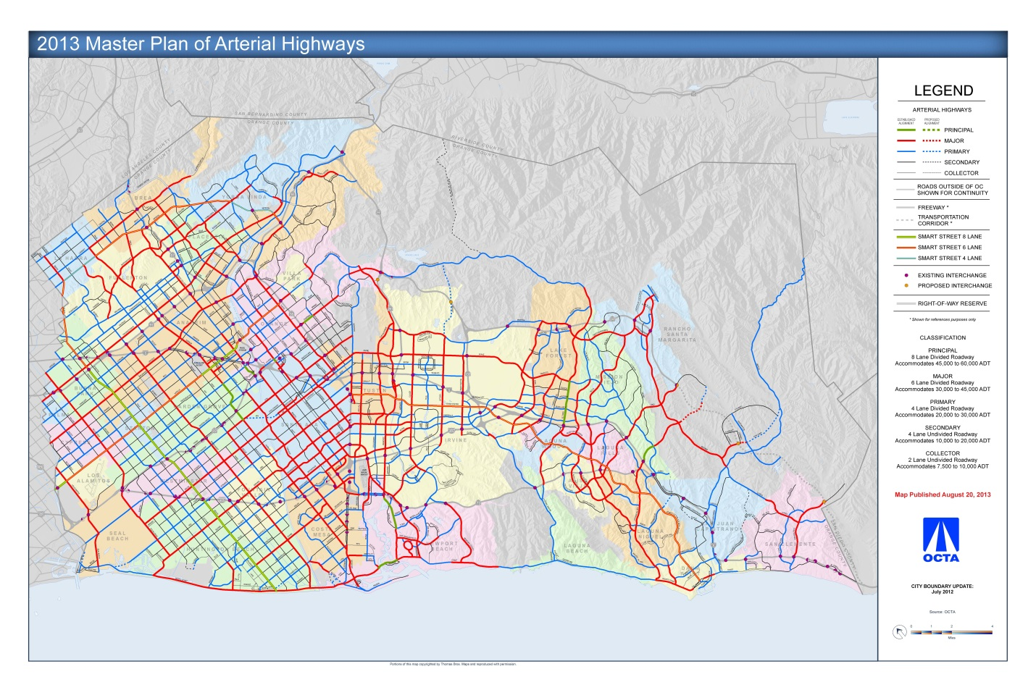

**http://www.octa.net/Freeways-and-Streets/Streets/Master-Road-Plan/Overview/**

**APPENDIX 2: ARTERIAL PAVEMENT MANAGEMENT SCORING CRITERIA**

The following is a list of criteria used to evaluate projects in the APM Program.



**APPENDIX 3: SEMI-ANNUAL REPORT FORM**

Project Title: ____________________________________________________

Agency: ________________________ Date: _____________________

|  |  |  |
| --- | --- | --- |
| Schedule | Original Completion Date | Current Completion Date |
| Draft Environmental Document |  |  |
| Final Environmental Document |  |  |
| Begin Design Engineering |  |  |
| Plans, Specifications, and Cost Estimates complete |  |  |
| Submit Request for Authorization for Const. (E-76) |  |  |
| Ready to Advertise |  |  |
| Award Construction |  |  |
| Project Completion (open for use) |  |  |

Funding Table:

Construction ($000’s)

|  |  |  |  |  |  |
| --- | --- | --- | --- | --- | --- |
| **Fund Source** | **Fiscal Year** | **Planned Obligation** | **Revised Allocation** | **Actual Expended** | **Remaining Allocation** |
|  |  |  |  |  |  |
|  |  |  |  |  |  |
|  |  |  |  |  |  |
|  |  |  |  |  |  |

Major Activities: _____________________________________________________________

_____________________________________________________________

_____________________________________________________________

_____________________________________________________________

Status: _____________________________________________________________

_____________________________________________________________

_____________________________________________________________

_____________________________________________________________

Issues: _____________________________________________________________

_____________________________________________________________

_____________________________________________________________

Name/Title: _____________________________________________________________

Phone: _______________________ Email: ________________________________

Note: OCTA may require additional information on performance of the project related to either air quality or transportation usage.

1. Design Standards by Caltrans’ Maintenance Technical Advisory Guide (MTAG) Volume I
2. For federally funded projects, expenditures prior to approval of the E-76 form will not be eligible.